Nama : Hafid Prasetyo Nugroho

NIM : 5301414029

Mata Kuliah : Pengolahan Citrda digital

1. Low pass filter

a.histogram gambar asli

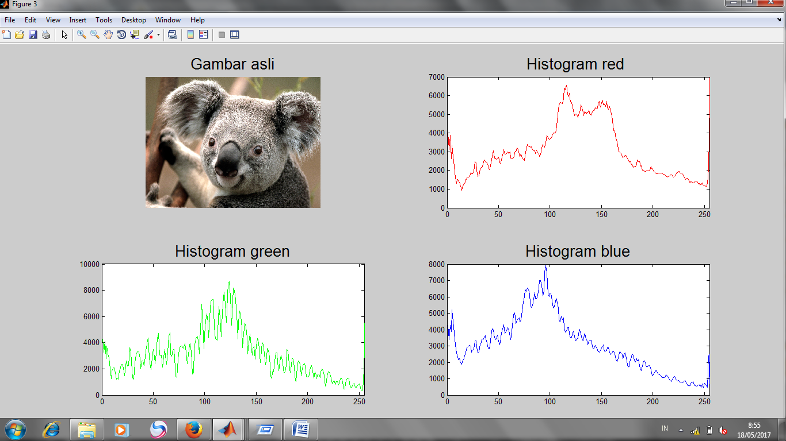

b. Hasil Low pass filter

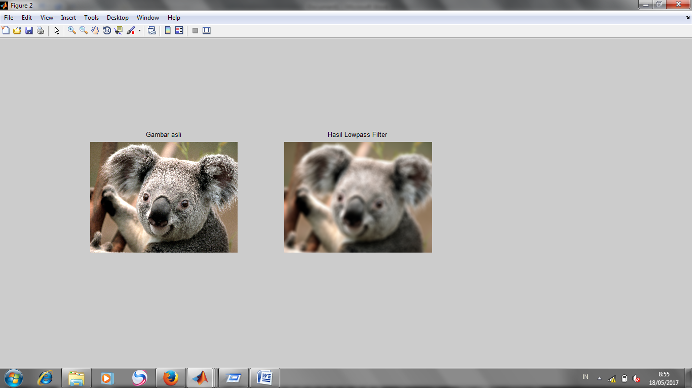

c.Hasil histogram lowpass

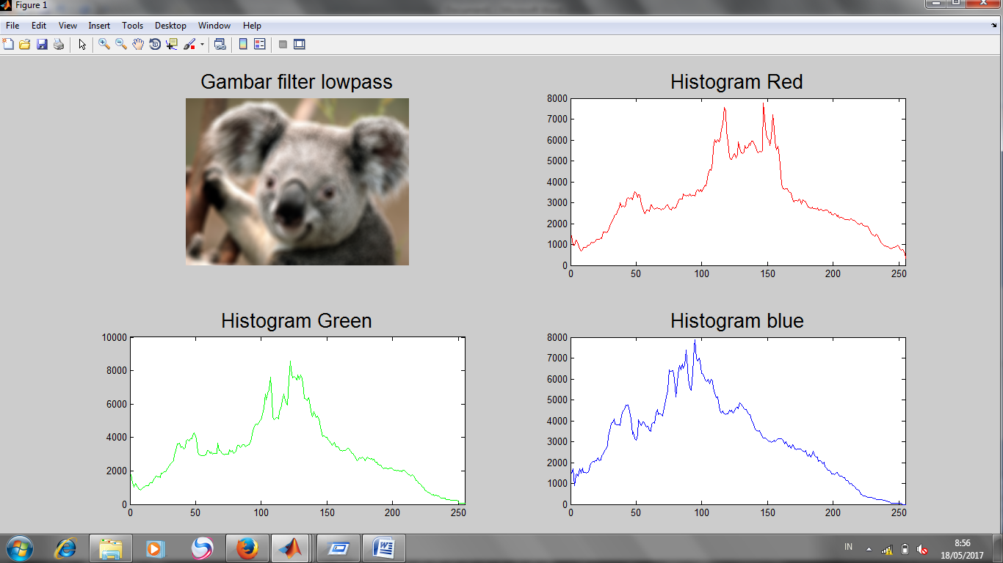

1. Highpass Filter
2. Histogram gambar asli

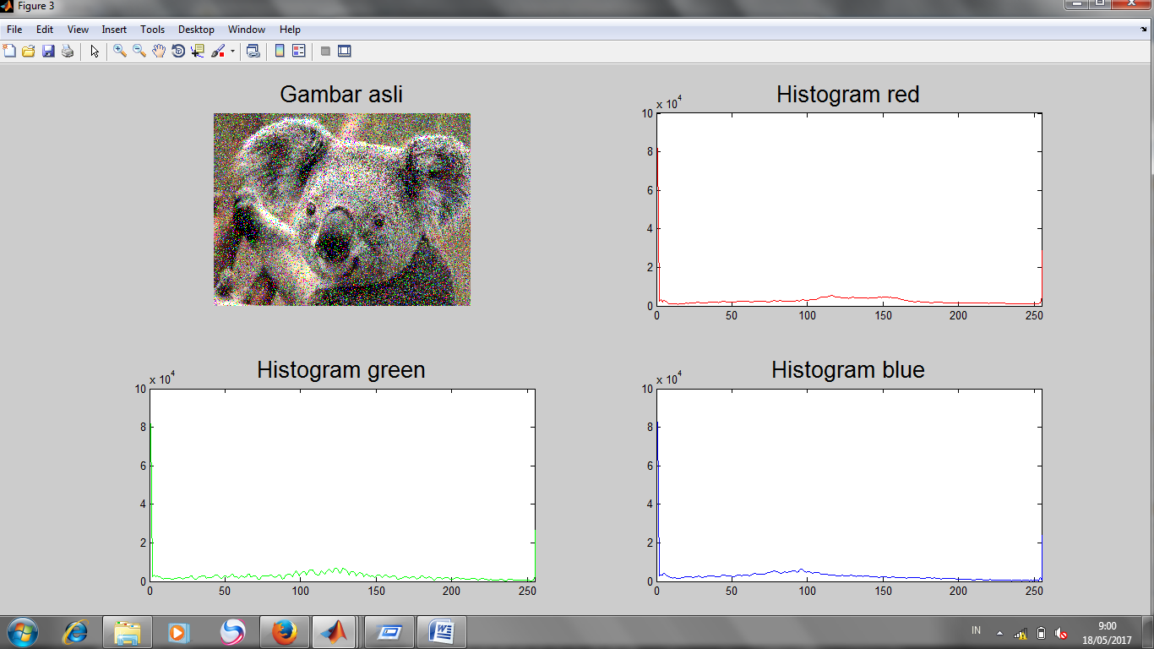

1. Hasil Highpass filter

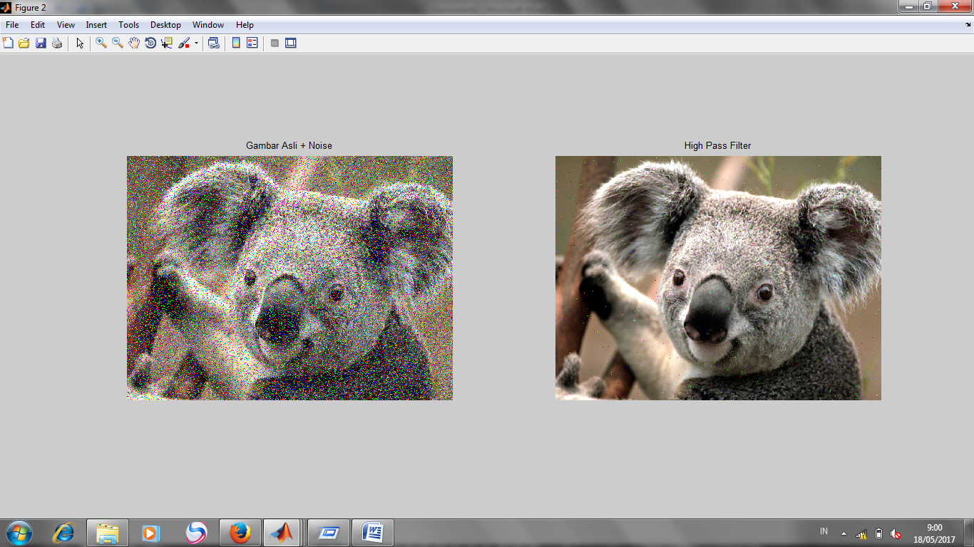

1. Histogram Hasil highpass filter

